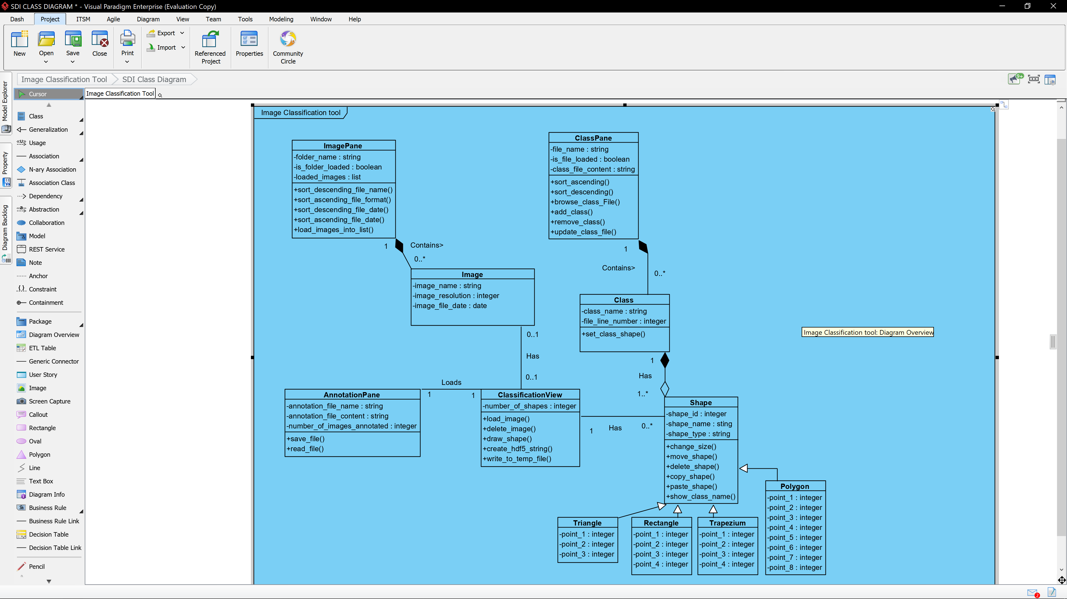

Image Class – Image Pane: an image must be included in at least one instance of an ImagePane, until an Image is loaded within the ImagePane an instance of the Image class won’t exist thus making it a composition.

ImagePane Class – Image Class: an ImagePane will contain zero or many instances of an image, depending on how many are loaded in.

Image Class – ClassificationView: An image can be loaded into a single instance of ClassificationView or not.

ClassificationView – Image Class: The ClassificationView can have a single image loaded into it or none.

ClassificationView – Shape Class: The ClassificationView can reference several instances of class Shape.

Shape Class – ClassificationView: Each instance of the shape class must be loaded into a single instance of ClassificationView.

Shape Class – Class Class: Each instance of a shape must be related to a single instance of a Class.

Class Class – Shape Class: Each Instance of the Class Class has between 0 to many shapes which will be linked to it. Relationship Class – Shape is aggregation as a class can exist without the need for a shape to exist.

Class – ClassPane: A Class Class must be included in at least one instance of a ClassPane, until a ClassFile is loaded in by an instance of ClassPane a Class instance wont exists thus making this a composition.

ClassPane – Class: ClassPane will contain zero or many instances of Class.

AnnotationPane – ClassificationView: One to one relationship as each instance of AnnotationPane will load an instance of ClassificationView.

ClassificationView – AnnotationPane: Single instance of ClassificationView relates to a single AnnotationPane.